**MASTERS DOCUMENTATION**

|  |  |
| --- | --- |
| **Application :** | NGERP |
| **Workflow :** | MASTERS |
| **Workflow Item Name :** | ROLE |

**Description :**

Role Is A Master Used To Control The User ‘s Access To The NGERP Application.

**Workflow Process :**

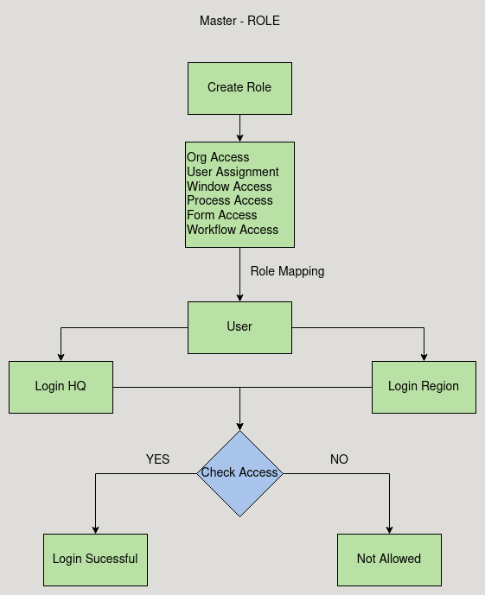

**Business Rules :**

* The Role Master screen is used to control the user access to the functionalities of the NGERP Application.
* There are Six Tabs In Role screen
  + - Org Access
    - User Assignment
    - Window Access
    - Process Access
    - Form Access
    - Workflow Access
* Org Access:

Org Access Tab is Used to give the user access to which organisation they are able to login.

* User Assignment:

This tab is used to assign user to the role.

* Window Access:

This tab is used to give the user access to the wiindows.

* Process Access

This tab is used to give the user access to the process that they can run.

* Form Access:

This tab is used to give the user to process the form.

* Workflow Access:
* Create a Role and give access to the Organisation on which the user want to login
* Create a user and map the role created.
* Now login to region, if the user has access to region then the login will be successful
* Else the organisation drop down does not show the region or HQ